Name: Ravin Godbole
PRN: B25CE1087
Div: CE 2, Batch A
-------------------------------------------------------------------
Experiment name: Simulation of Electrical Switch
Topic: Screen Timeout

Screen Timeout Program

Aim: -

The aim of this report is to explain what screen timeout is and to create a program for identifying whether the screen will be on or off for a given screen timeout.

Research: -

Screen timeout refers to the duration of inactivity after which your device's display turns off to conserve power.
The screen timeout of electronic device can be changed as per the preference of the user in the settings menu in their device.
Screen timeout helps in conserving and extending battery life on portable devices such mobile phones, laptops, tablets etc.
However, an increase in screen timeout can lead to an increase in battery consumption and decrease in the performance of the device.
Screen timeout can also help in privacy and security of personal information as a shorter screen timeout can help protect sensitive information by obscuring the screen when you step away from your device.

References: -

- https://windowsloop.com
- https://www.solveyourtech.com
- https://www.lifewire.com

Analysis: -

For mobile phones, screen timeout can be adjusted as follows,
- Go to your device's Settings menu.
- Navigate to the Display section.
- Select the Screen timeout option
- Choose your desired Screen timeout length.

Minimum screen timeout that can be kept is 30 seconds while maximum screen timeout that can be kept in 10 minutes (600 seconds).

Ideate: -

To change the screen timeout, you can just search it on Google and instructions for your device will be available on various websites.
For e.g., if you own a Samsung device, the procedure will be available on their official website www.samsung.com .
Similarly, the procedure can also be found out on the official websites of other mobile phone companies.

Steps to write program for finding whether the display will be ON or OFF for given screen timeout and input time are as follows: -

START

Input the screen timeout as “n1” in seconds

Input a time “n2” in seconds

C1

C1

If n2 > n1

T

F

Display will turn OFF
Display will remain ON

End

Build: -

#include<stdio.h>
int main() {

int t1;
printf("Enter Screen Timeout :");
scanf("%d",&t1);

int t2;
printf("\nEnter Input Time :");
scanf("%d",&t2);

if(t2<t1 && t2>0)
printf("Display will be ON");
else if(t2>t1 && t2>0)
printf("Display will be OFF");
else
printf(“Invalid Input”);
}
Testing: -
Test Case 1: -
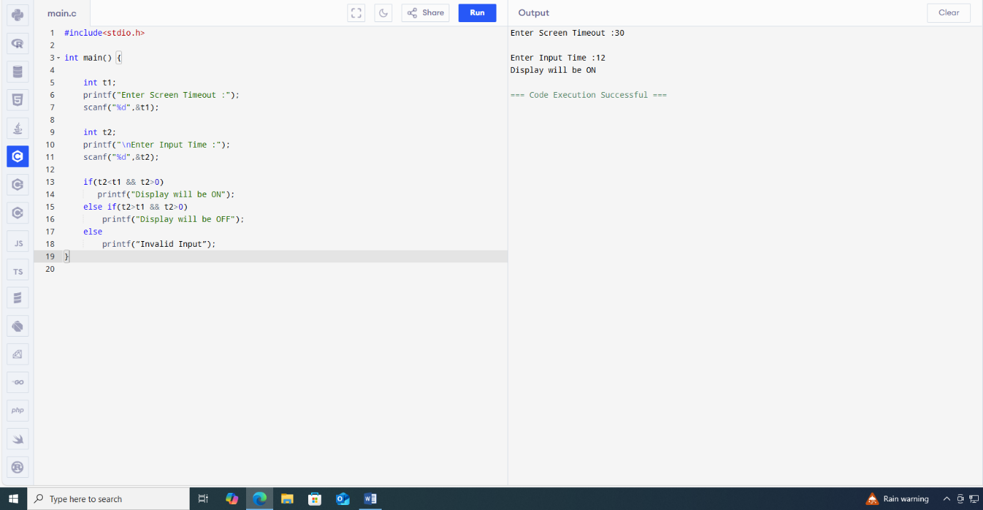

Test Case 2: -
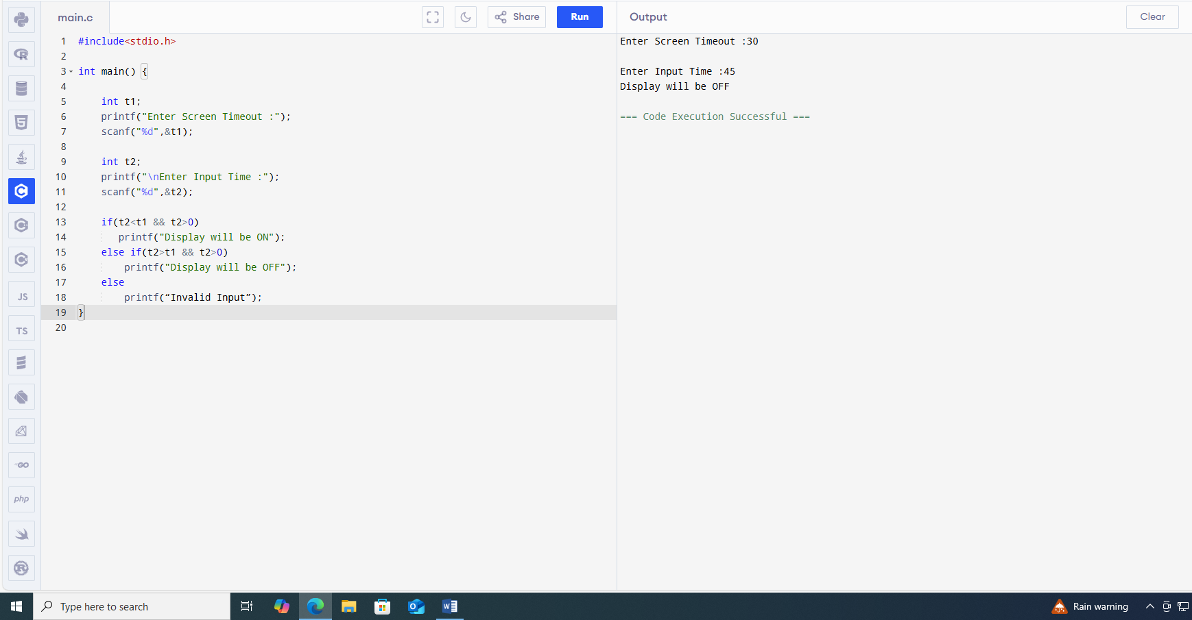

Test Case 3: -
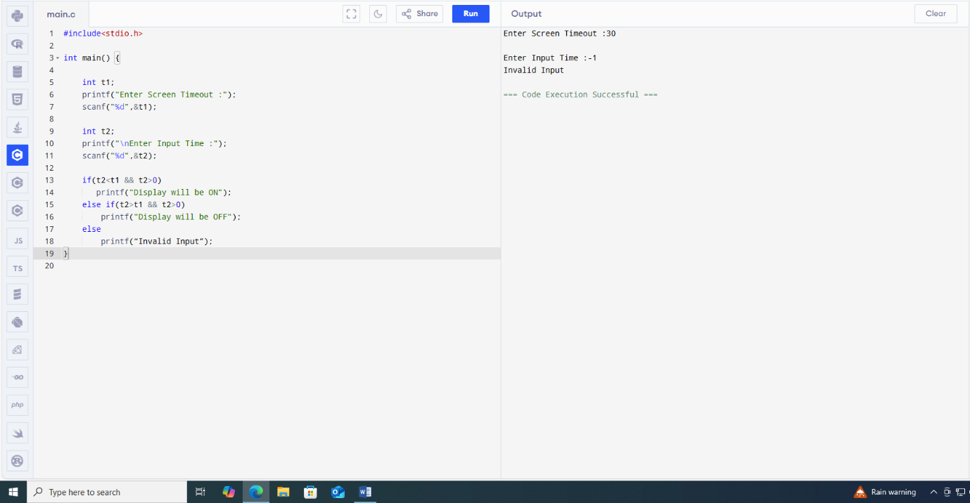

Link: -

https://github.com/Ravin-dev-129/Report_on_Screen_Timeout

Conclusion: -

Thus, the code is functional as shown by the test cases above and so we have achieved our objective.

